Lab 7 manual: RC circuits
Dr. D. Beznosko
5/3/2025
For PHYS 1112L only.
(Lab outcomes: non-mechanical oscillating systems, linearization of the exponential fit and error bars handling.)

Abstract
A harmonic oscillator is, arguably, the most important single concept in physics. This approach is used to study systems that are conducting any repetitive action, including everyday things that we face such as heartbeat, walking, talking and so on. Non-mechanical oscillations can be explored using a simple RC system. Conversion of the error bars when trying to linearize an exponential plot will also be explored to show which points are more contributing.

Introduction
Quantum particles, shock absorbers, data transmission, computers, brain waves – what do they have in common? They are all examples of the oscillator-based systems. Can you name a few of those? Where else oscillators can be used? Can we use them to describe everyday things?

Experimental Setup
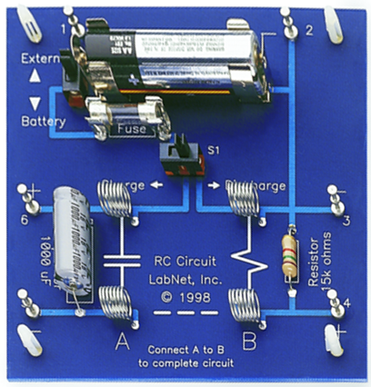
The setup in Figure 1 has a RC circuit board with the power supply and voltage probe connected to it.
To voltage probe
To power supply
z
z
z
z
z
Figure 1: The experimental setup schematic. A circuit board with a capacitor and a resistor is connected to the power supply and a voltage probe.

Procedure
The goal is to find the RC constant of the circuit and compare with the listed value.
First, make sure that all wires are disconnected from the circuit board including AB. Use multimeter to measure the resistance of the resistor and compare with the color code. Do the values match? What are the errors and uncertainties here? And from color code?
Connect all wires and short AB. Make sure that no battery is inserted, the top switch is in ‘extern’ position and the S1 switch is in ‘charge’. Set the power output of the PASCO [1] computer interface to 5 volts and select option so that output starts with data acquisition. Note this value as it will be your $V_{0}$. We can take it as ‘perfect’.
Start data acquisition. The Voltage plot will show that capacitor is charging. What is the $\frac{1}{e}\left(thatis,RC\right)$ charging time for this circuit from the listed nominals for the circuit elements? Wait for at least 6-7 periods to make sure that the capacitor is charged. After that, move the S1 switch into the ‘discharge’ position and wait for the same amount of time. Finally, the values for voltage should not be visibly changing. Use this end of tail to measure the statistical error as the stdev of several tens of points (ask instructor for details). Do a short run with the power supply disconnected from the circuit to see if there is an offset from 0 – check the mean and stdev. If the mean is > stdev, this is your systematic error, and stdev is part of the statistical – combine with the previous value in quadrature. If stdev is larger – this is your systematic error. Combine all errors into a single one. Save relevant parts of the capacitor discharge and change data.

Experimental Data
The results of the measurements should be organized as Table 1 or similar. Think about how to organize this table. The error can be listed in a different column or as value ± error unit. Don’t include all data values here, only relevant means, stdev etc. In most cases, individual data points are not needed, especially for computer-based labs. What is the time error if needed?
Table 1: Experimental data.
Time, s | Voltage, V

Provide description about each entry as needed, don’t just leave the table without text in this section. Organize well so that data takes up less space, but everything needed is included.

Theory
The discharging (eq 1) of the capacitor is given as:
$$V=V_{0}e^{\frac{−t}{RC}}\left(1\right)$$
where $C$ is the capacitor value, $R$ is the resistor value on the RC board used.
Remember to include all needed equations in the Theory section, not the Analysis! For example, errors for the axes, linearization, and error on $τ=RC$ from components.

Analysis
Take capacitor discharge data and plot V vs t. Add V error bars; time is assumed ‘perfect’ here. Do the exponential fit (expo). What is the meaning of the result that is produced by the website? What is the RC value from it?
The exponential fit is not always available or easy to use. We can try and linearize the data and use the linear fit and regression on it as usual.
To do that, make the plot of the $ln\left(V\right)vst$. Show the result of taking the ln of eq. 1 – simplify it into the form $y=ax+b$. Which part is the slope and what is the offset in this case?
The plot is now linear. The only trick is how to transform the error for V. As it can’t be done using simplified equations, here is the answer: $V_{new}=ln\left(V_{old}\right),ΔV_{new}=\left|\frac{1}{V_{old}}∙ΔV_{old}\right|$. Note which points have bigger error bars? What does that tell you about which points are more important for the exponential fit? Do the linear fit using the website as usual (using pol1). Time is assumed ‘perfect’ so there is no $Δt$ and only y-error bars.
Compare the RC from slopes of both plots to the value from the capacitor marking and resistor measurement within error.

Conclusion
Comment on your result and the methods used to find it – which one is more trustworthy? What did you learn in performing this measurement? Where else can it be used? Can this experiment be improved?

References

[1] | PASCO Scientific, 10101 Foothills Boulevard, Roseville, California 95747 USA.

